Nabeel Ahmed
D209 Task 1 Performance Assessment
04/30/2025

- Research Question:
  - Can we predict whether a telecom customer will churn based on their service usage and demographic information using the k-nearest neighbors (KNN) classification method?
  - The goal is to build a predictive model to identify customers at risk of churning so the telecom company can target them with retention strategies.
- Method Justification:
  - The k-nearest neighbors (KNN) classification method analyzes the dataset by calculating the distance between customers based on selected features and assigning the churn status based on the majority class of the nearest neighbors. The expected outcome will be the model will accurately predict whether a customer will churn, allowing the company to proactively identify and retain high-risk customers. (Kartik)
  - KNN assumes that customers with similar feature values are likely to have similar outcomes. (Kartik)
  - Library:
    - Pandas: Used for data loading, cleaning, and manipulation.
    - scikit-learn: Used to perform the KNN classification, split data, and
evaluate the model.
    - numpy: Supports efficient numerical operations.
- Data Preparation:
  - The goal of data preprocessing is to prepare the dataset for the k-nearest
neighbors (KNN) classification method by ensuring that all input features are
properly formatted, scaled, and encoded. (Korstanje)
  - Relevant Variables and Types
    - Tenure - Numeric
    - MonthlyCharge - Numeric
    - Income - Numeric
    - InternetService - Categorical
    - Contract - Categorical
    - TechSupport - Categorical
    - OnlineSecurity - Categorical
    - Churn (Target) – Categorical
  - Data Preparation Steps:
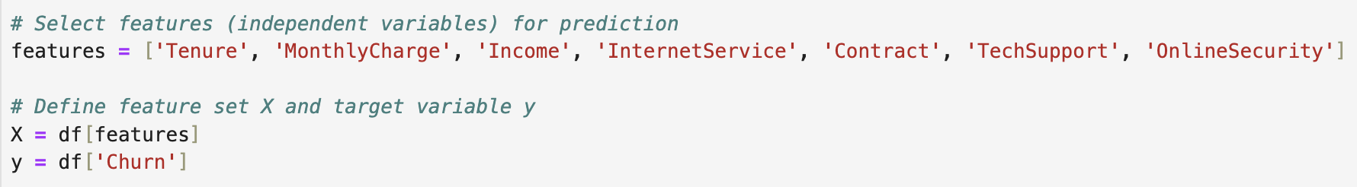
    - Select Relevant Features: We select a subset of relevant variables from the dataset that will be used as features for the model (X) and the target
variable (y). The target is whether the customer churned or not.
    - Encode Categorical Variables: KNN can only work with numeric data. So, we use one-hot encoding to convert categorical variables in X into binary columns. For the target variable y, we use label encoding to convert
'Yes'/'No' to 1 and 0.
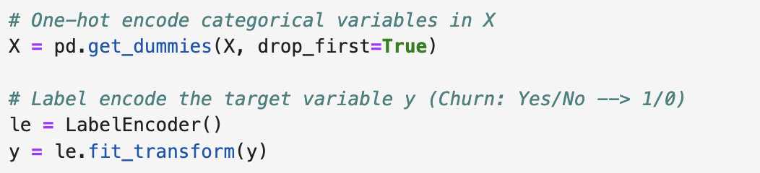
    - Scale Numeric Variables: KNN uses distance between data points. If
features are on different scales, it can skew results. We use StandardScaler to normalize features so they all have a mean of 0 and standard deviation
of 1.
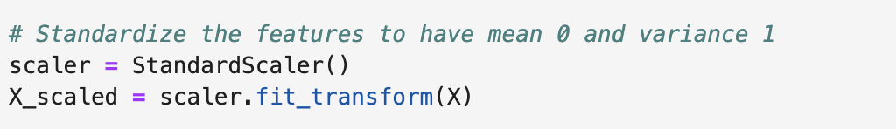
    - Create and Save Cleaned Data: We combine the scaled features and the
encoded target variable into a single DataFrame. Then we save it as a new file for further analysis in the next steps.
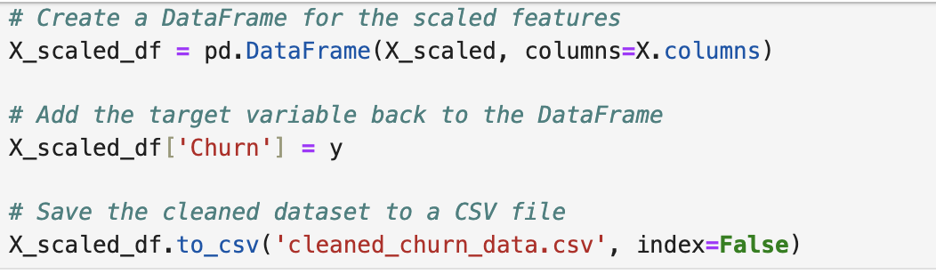
  - Cleaned CSV file attached to submission called:
“cleaned_churn_data.csv”
- Analysis:
  - Files are attached to submission.
  - The k-nearest neighbors (KNN) classification model was used. The data was split into training and testing sets. The model was trained on the training set and used
to predict churn on the test set. Model performance was evaluated using accuracy, area under the curve (AUC), and a Receiver Operating Characteristic (ROC)
curve.
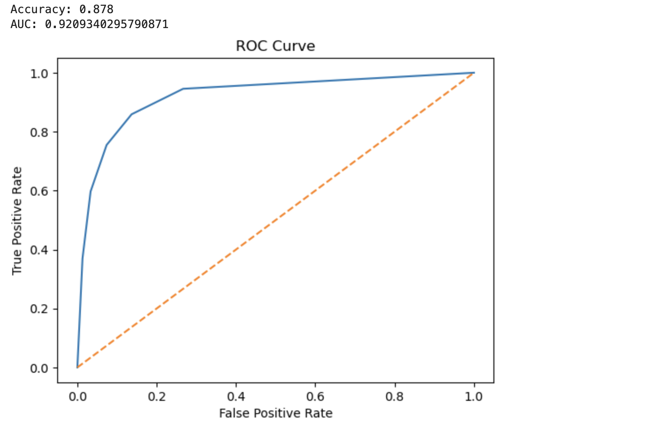
  - Code for Above results:
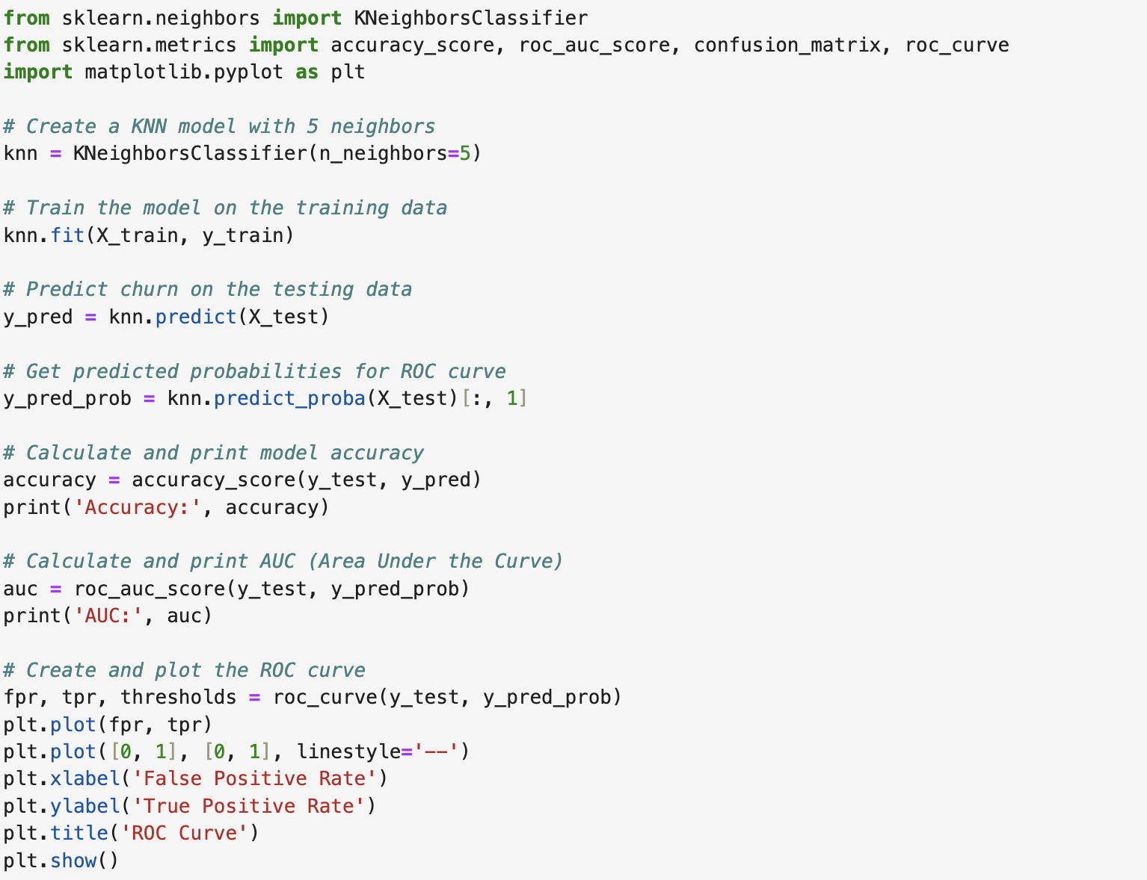
- Data Summary and Implication:
  - The KNN model had an accuracy of 0.878, meaning it correctly predicted churn for about 88% of the customers. The AUC was 0.921, which shows the model is very good at separating customers who churned from those who didn’t. A high AUC like this means the model can make strong predictions.
  - The model’s results show it’s a strong tool for predicting churn. With this, the
company can focus on customers most likely to leave and offer things like
discounts, better service, or loyalty rewards. Using the model would help the
company save customers before they leave, which could have a big impact on
revenue and customer relationships.
  - One limitation is that KNN treats every feature as equally important when
calculating distances. Things like contract type or how long someone’s
been a customer might matter more than other features. Since the model doesn’t
know that it could miss some patterns.
  - The company should use the model to find customers who are most likely to
churn and target them with special offers or better service. They should also keep updating the model over time, because customer behavior can change and staying updated will keep the predictions accurate.
- Panopto Link:
Folder: https://wgu.hosted.panopto.com/Panopto/Pages/Sessions/List.aspx#folderID=%22dcfdf6dd-9e05-4665-b1b6-ac72018a20ab%22
Video: https://wgu.hosted.panopto.com/Panopto/Pages/Viewer.aspx?id=ffba6808-e8f3-47a7-bd23-b2d0000a075d

- Sources:
Kartik. (2025, January 29). K-Nearest Neighbor(KNN) algorithm.
GeeksforGeeks. https://www.geeksforgeeks.org/k-nearest-neighbours/
Korstanje, J. (2022, September 1). The K-nearest neighbors (knn) algorithm in
Python. Real Python. https://realpython.com/knn-python/
W3schools.com. Python. (n.d.). https://www.w3schools.com/python/python_ml_auc_roc.asp

